In order to install the firmware in your printer for either updates or tweaks you might perform you need a couple of things:

* Arduino IDE application to read and compile the Marlin Source Code.
* Arduino library Addon to allow communications with the LCD panel used.
* These instructions☺.

Just remember any tweaks you may do you do at your own risk – I cannot be responsible for any changes you make to the software as I have absolutely no method of determining what you did in the first place ☺

**Obtaining the Arduino IDE**

The first thing you will need is the Arduino IDE application. This is free open source software you download from the Arduino website:

<https://www.arduino.cc/en/Main/Software>

The current version as of this writing is Arduino 1.6.6 as will work fine – there are different versions for different operating systems (Windows, Mac and Linux) so be sure to select the appropriate version for your computer.

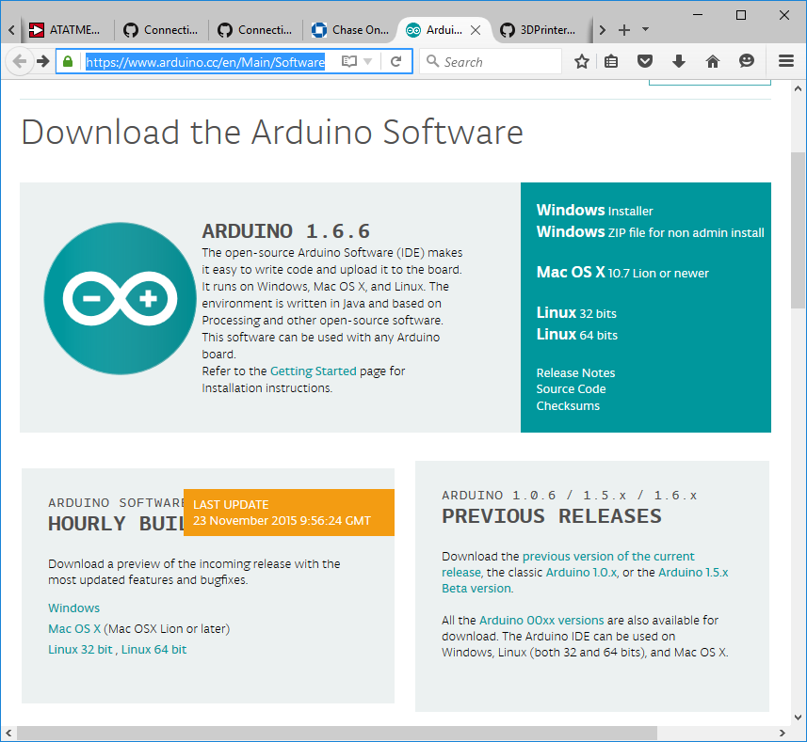

Follow the directions provided to install the IDE applications software on your computer.

**Locating the IDE installation folder**

You now need to determine where the IDE application is installed on your computer. You will need this information in order to determine where the additional software library is going to be installed in the IDE applications folder.  
  
Once you have downloaded and installed the application if you used the default installation your version (in Windows) should be in the "C:\Program Files (x86)\Arduino" folder.

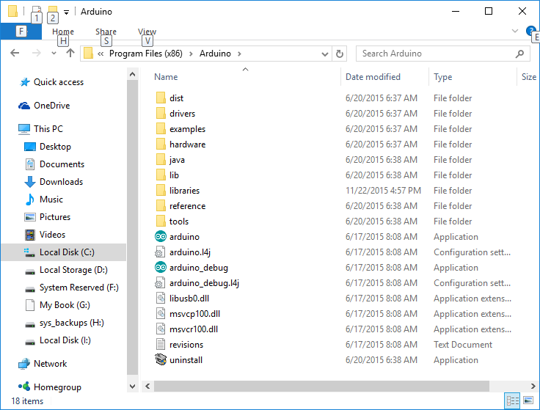

You can determine where your version is in the computer by performing a search for arduino.exe which is in the folder we are interested.

We are going to install the additional library needed for the proper operation of the LCD panel on the Prusa i3 Printer.

**Obtaining the firmware source code and addon libraries**

In order to perform the next steps you need to obtain the Marlin firmware source code and the add-on library needed.

Go to <https://github.com/garynmckinney/Prusa-Programming> and use the Download ZIP on the right side of the screen to download the source code from the site.

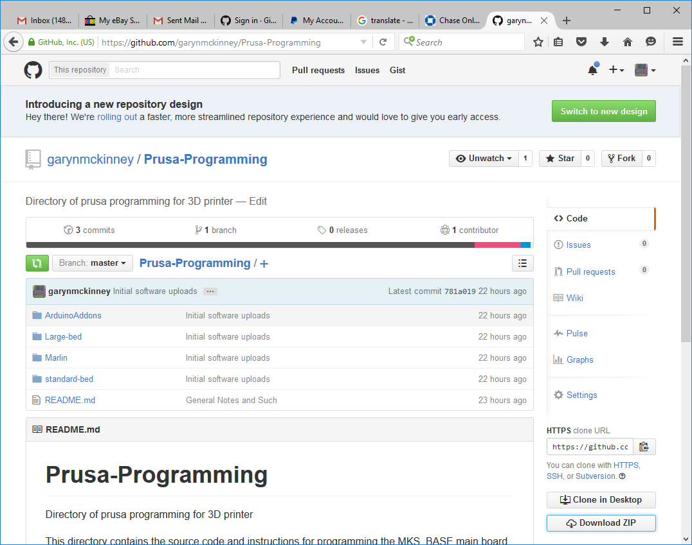

Unzip the file you downloaded somewhere you can find it on your computer.

**Installing the addon library in the Arduino IDE**

Open the folder where the arduino.exe file is located. You should see a folder called “libraries”.

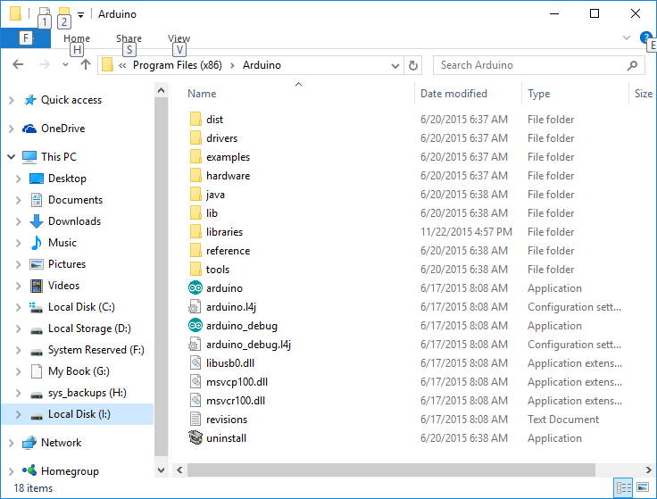

Open a second Explorer window where you downloaded and unzipped the Prusa Programming zip file.

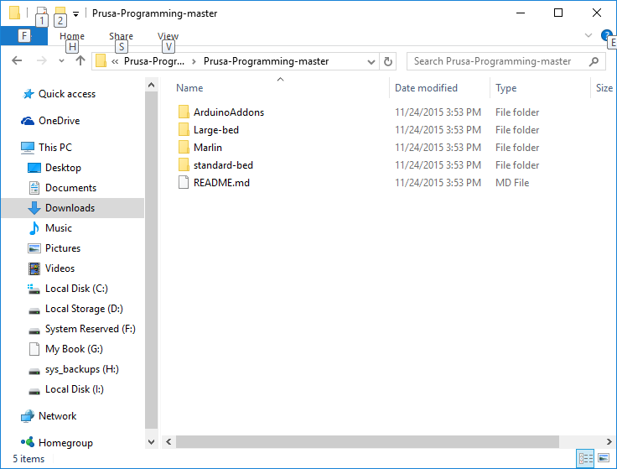  
  
Locate the ArduinoAddons folder and open it.

Select the folder with the version of the Arduino IDE you have – if you downloaded the latest version then open the Arduino_1.5.x folder.

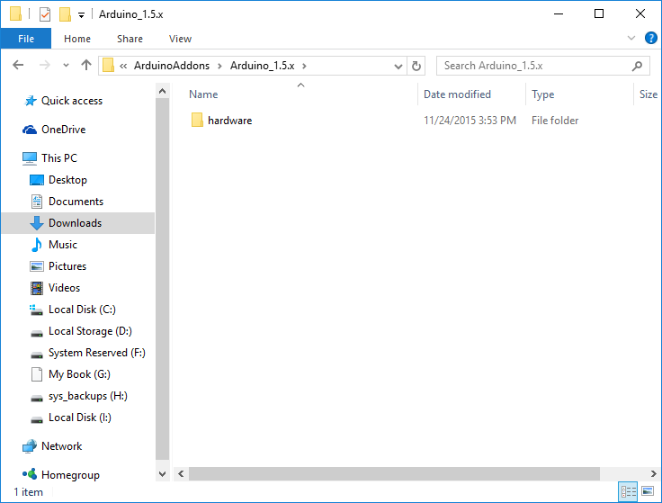

Open the hardware folder. Open the marlin folder. Open the avr folder. Open the libraries folder.

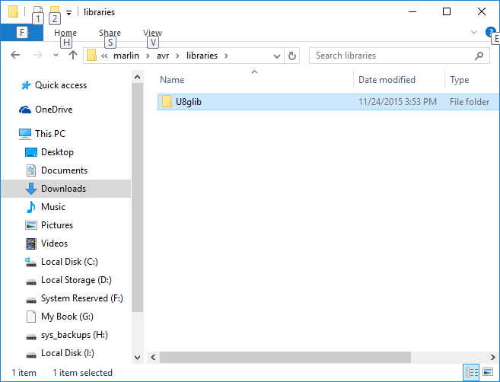

Inside the libraries folder you will find a folder called “U8glib” – this is the folder of interest to us.

Copy the U8glib folder from the Arduino_1.5.x folder to the Arduino IDE libraries folder.

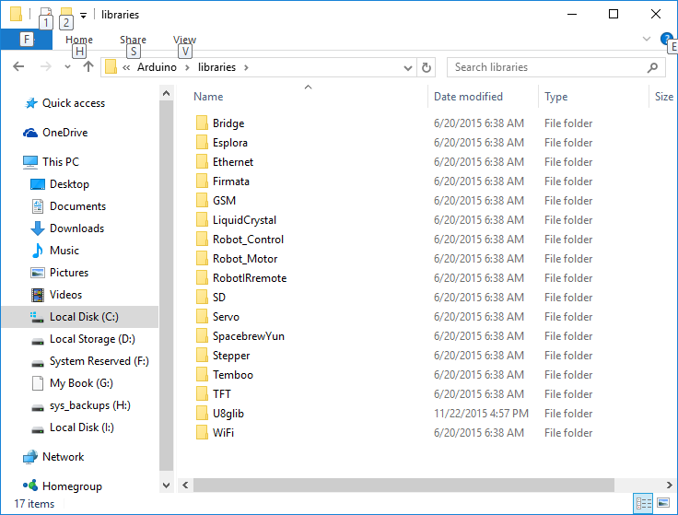

Great – now you have installed the required library that allows the LCD panel to operate properly. ☺

**Building and installing the firmware in the printer**

Build the firmware for installation in the printer’s main board is a fairly easy process but there are a couple of things you need to do first.

* Copy the proper configuration.h file for the printer you have into the source code directory

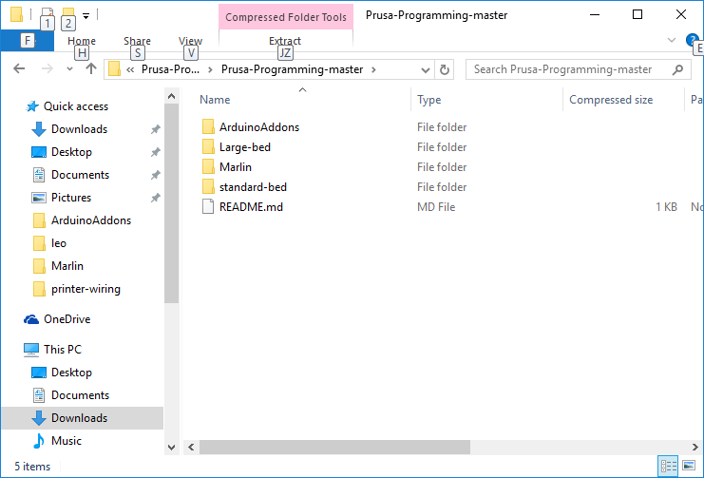

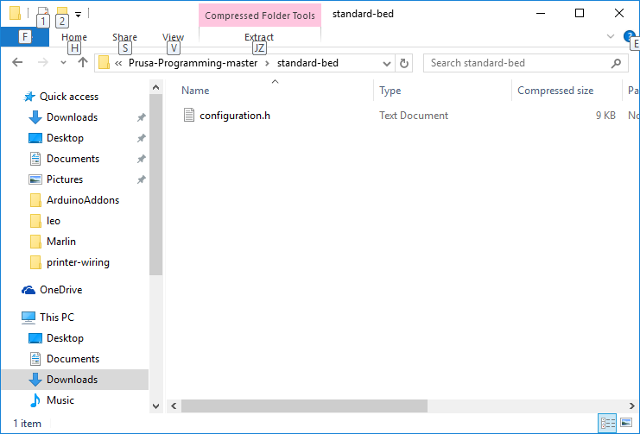

Copy the printer’s configuration.h file from the standard or large-bed folder to the Marlin folder. This file configures Marlin correctly for your version of the printer – mainly the print bed size settings.

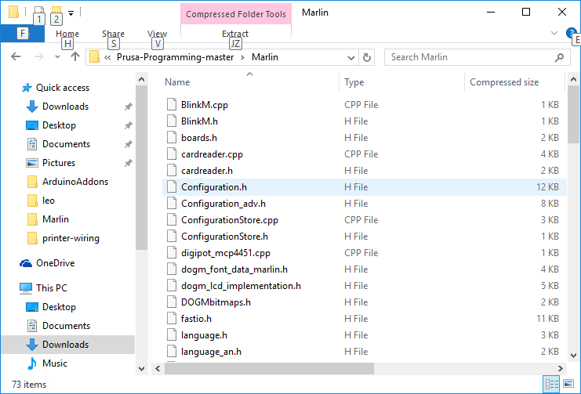

* Connect to the printer’s main board through the USB port.
* Open the Arduino IDE application – once it is open you will see the following application:

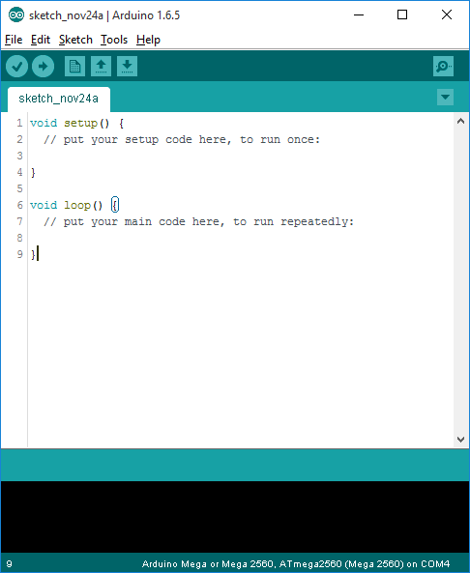

The IDE needs to be configured for the type of processor, device and com port used for programming the main board – perform the following steps to configure the IDE.

* Select the correct serial COM port where your printer is connected through the USB port.

At the top of the window select Tools 🡪 Port then the COM port the printer is connected.

* Select the correct device type to be programmed

At the top of the window select Tools 🡪 Board 🡪 Arduino Mega or Mega 2560

* Select the correct processor type to be programmed

At the top of the window select Tools 🡪 Processor 🡪 ATMega2560 (Mega 2560)

Once you have completed the above steps the IDE application is configured to program the main board on the printer ☺

Close the Arduino IDE application – we will be opening it again in the next steps but closing it will insure all the changes made will take effect when we open the application again to be sure everything is configured correctly. Nothing worse than fretting over a bad compile than to find something would not setup properly until the application had been closed then open again to activate it.

**Compiling and Installing the Marlin Firmware**

Open the Marlin Source Code with the Arduino 1.X.X IDE you previously installed by double-clicking on the Marlin Arduino file.

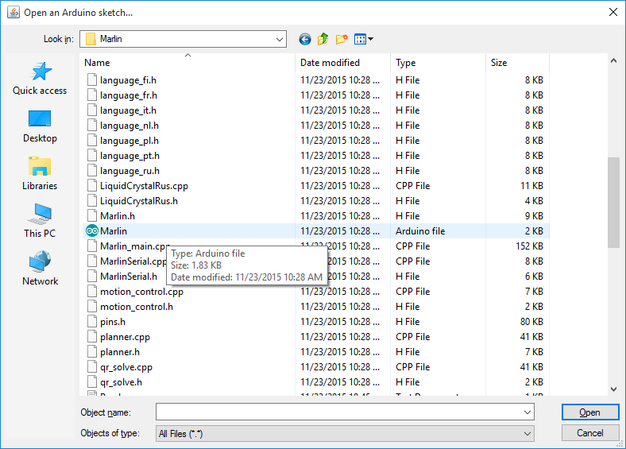

You should see the following IDE window open

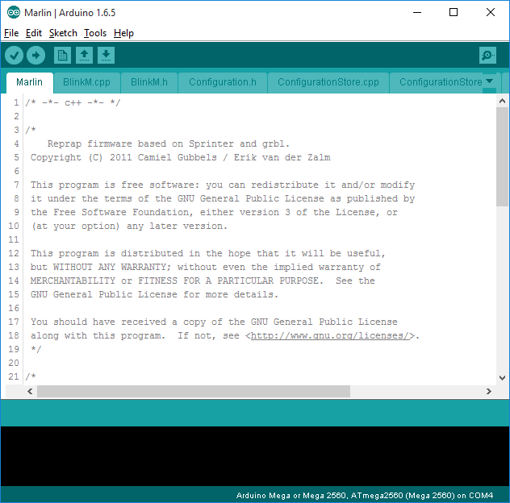  
  
At the bottom of the window you should see what is displayed above and the Com port should be the one you selected earlier.

If this is not the case go back over the previous steps to configure the Arduino IDE to fix the issue.

You cannot proceed beyond this point until this has been rectified (fixed).

**Installation of Firmware**

The next step is very easy – Click on the right-arrow in the circle under the Edit selection at the top of the IDE application window (see below image) to start the compile process.

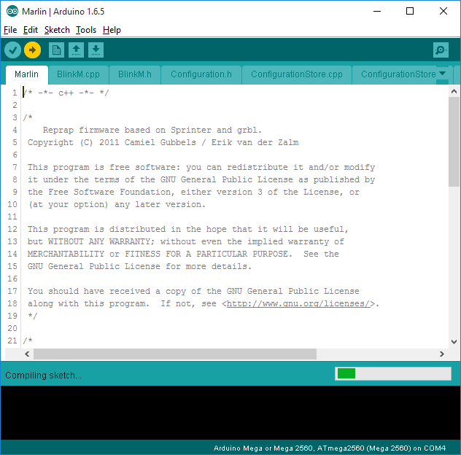

Once the IDE application completes the compile step for the firmware it goes immediately into the uploading of the compiled firmware to the main board itself. This step happens if there were no errors detected during the compilation process and if you followed all the previous steps properly you will have no errors shown.

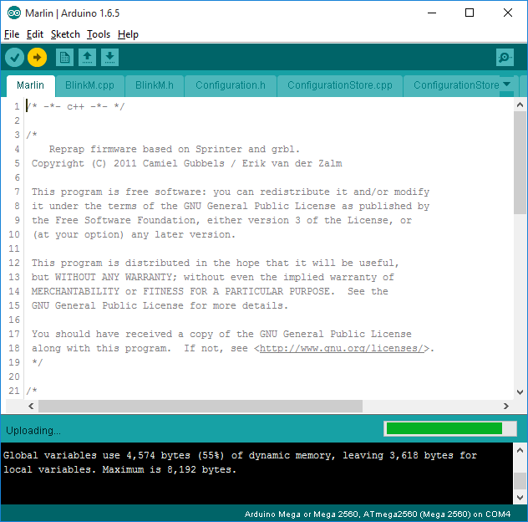

The above image shows the IDE application is uploading the compiled code to the main board on the printer. If you look at the main board you will see three blue LED lights – One will be on solid and the other two will be blinking rapidly. The blinking LED lights are the transmit and receive LEDs for the USB interface and shows there is indeed data transferring from your computer to the main board ☺

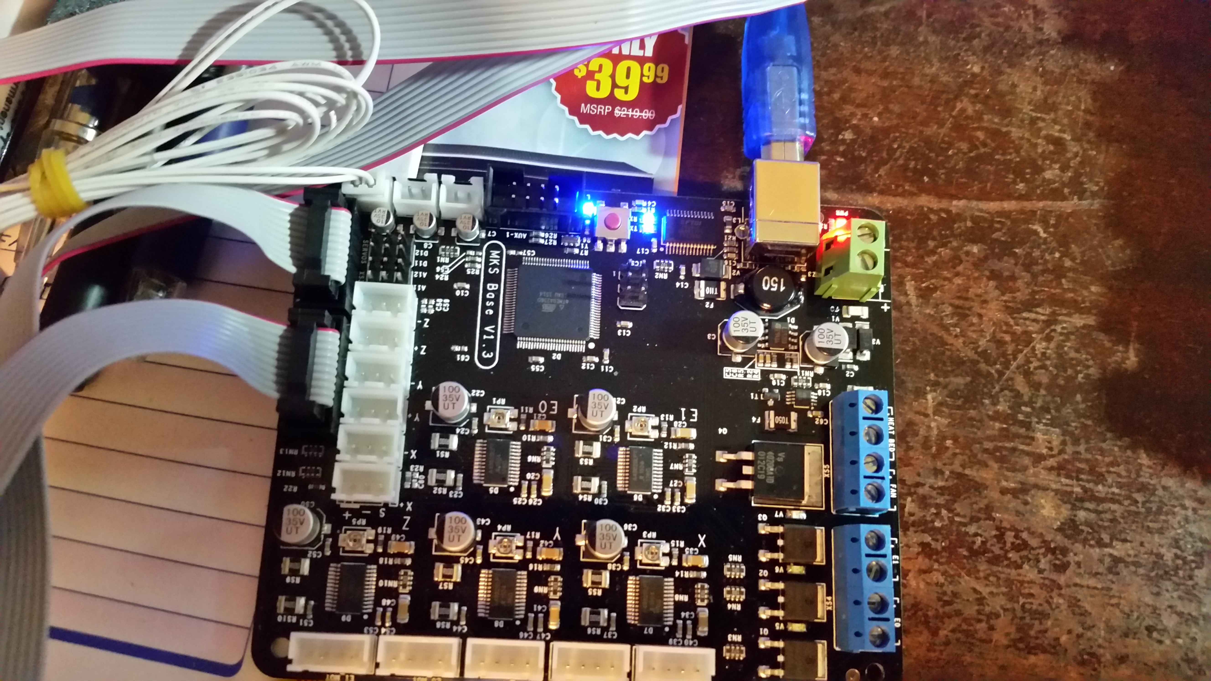

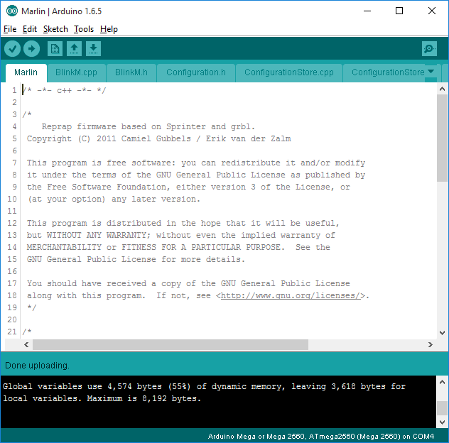

Once the IDE application has completed the firmware upload to the printer’s main board you should see the ‘Done uploading’’ message on the IDE application and no errors displayed in the status window at the bottom.

You should see the following on the LCD display:

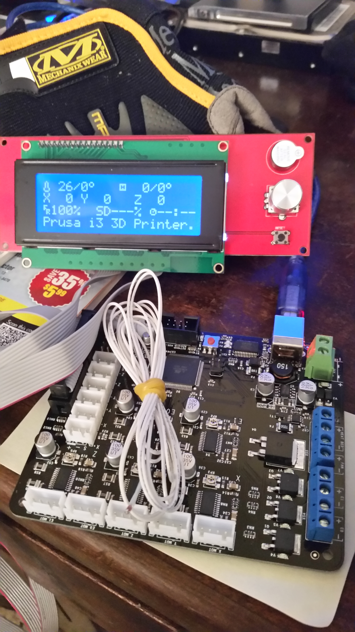

Congratulations – you have successfully completed the installation of the firmware on your printer’s main board. Enjoy.

Where to go from here – now you have the ability to make changes to your firmware in your printer. You can change all sorts of settings in the configuration.h file for your printer – be careful and understand what you are changing before you start making changes otherwise you might change something that causes your printer to attempt to perform something it cannot physically perform and cause something to break!

For further reading on the configuration of the marlin software check out this link:

<http://airtripper.com/1145/marlin-firmware-v1-basic-configuration-set-up-guide/>

While this is not directly related to your Prusa i3 printer directly it has a really good write-up of the different settings in the configuration.h file. ☺ It is a good read and will help you understand some of the settings available to you that will allow you to tune your printer to perform how you would like (within reason of course).  
  
Thank You,

Gary N. McKinney